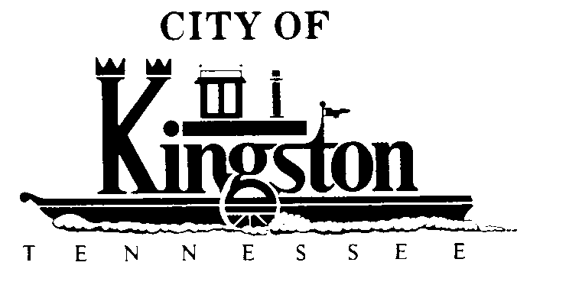

WORK SESSION - KINGSTON CITY COUNCIL
October 4, 2011 – 6:00 P.M.
KINGSTON COMMUNITY CENTER – ROOM C

A G E N D A

- Call to order

- Invocation and pledge

DISCUSSION REGARDING THE FOLLOWING ITEMS:

- Public Relations - Mr. Ridge Richardson

- Update on Grants - Mr. Jacks

- Recreation and Trails Program Grant Application for a “Blue Way” in Kingston - Mr. Ross

- An Ordinance to Amend Title 2, Section 2-101 of the Kingston Municipal Code to Reduce the membership of the Parks and Recreation Board from 12 Members to 9 Members (Housekeeping measure--this ordinance is not included in the new Code Book)

- An Ordinance to Adopt a Code of Ethics for the City of Kingston, Tennessee (Housekeeping measure--this ordinance is not included in the new Code Book)

- Execution of a Contract With Stethan-Smith Construction Company in the Amount of $2,255,932.37 for Ladd Greenway Project Pursuant to Receipt of Required Bonds, Insurance Documentation, and Interim Financing

- Interim Financing for the Ladd Landing Greenway Project

- Change Order No. 1 - United Utilities, Inc. in the Amount of $924.07 for Rubber Gasket Material

- Debt Policy - Ms. Brewer

- City Hall - Councilman Neal

- Quarterly Report - Ms. Brewer

- Street Name Changes
  - Change Bailey Road to Bailey Road North and Bailey Road South (From Highway 70)
  - Change Old North Kentucky Street From Hardee’s to the Car Wash to Earl Manis Drive

