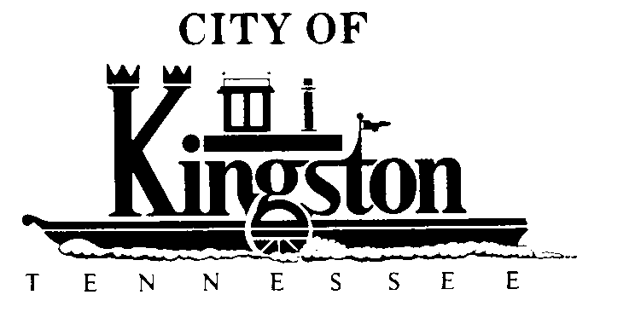

REGULAR MEETING
KINGSTON CITY COUNCIL
NOVEMBER 8, 2011 – 7 P.M.

A G E N D A
- Call to order
- Invocation and pledge
- Roll call
- Approval of Previous Minutes
  - October 11, 2010
- Citizen Comments/Persons to Appear
- Reports
- Reports by Mayor and Council Members
  - Recognition of Councilman John Byrkit’s Completion of the UT-MTAS/TML Level I Elected Officials Academy
- Department Reports
- City Manager’s Report
- Report by Rockwood Electric Representative – Council Member McClure
- Transportation Committee Report – Council Member White
- City Hall Building Committee Report - Vice Mayor/Chairman Tim Neal
- Grant(s) Report - Mr. Steve Jacks

- Addition of Items to the Meeting Agenda Received After Close of Agenda Deadline (By Unanimous Consent of All Members Present)

- UNFINISHED BUSINESS
- Second Reading of an Ordinance to Amend Title 2, Section 2-101 of the Kingston Municipal Code to Reduce the membership of the Parks and Recreation Board from 12 Members to 9 Members

- Second Reading of an Ordinance to Adopt a Code of Ethics for the City of Kingston, Tennessee

- Second Reading of an Ordinance to Amend the Ordinances of the City of Kingston to Remove Restrictions on Domicile and Residency Eligibility to Receive a License for Retail Liquor Sales

- NEW BUSINESS

- Approve and Authorize a Moody’s Application for Regional municipalities Issuer Rating for the City of Kingston

- Adopt Resolution No. 11-11-8-1 Establishing a Fund Balance Policy for the City of Kingston

- Adopt a Resolution Imposing a Temporary Moratorium on the Permitting or Approval of New Pain Management Clinic’s Within the City of Kingston; Adopting Findings; Providing Definitions; Providing for Penalties; Providing for Severability; Providing for an Effective Date

- First Reading of an Ordinance Regulating the Use of Engine Compression Braking Devices

