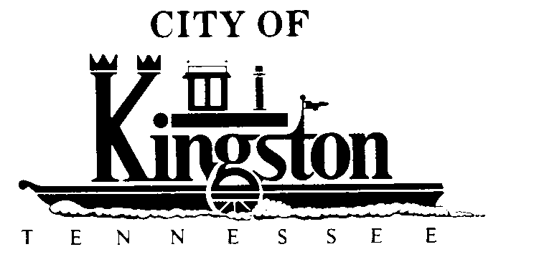

EXECUTIVE SESSION
FEBRUARY 1, 2011 - 5:30 P.M.
(CITY ATTORNEY AND COUNCIL MEMBERS ONLY)

WORK SESSION - KINGSTON CITY COUNCIL
FEBRUARY 1, 2011 – 6:00 P.M.
KINGSTON COMMUNITY CENTER – ROOM C

A G E N D A

- Call to order

- Invocation and pledge

- Citizens Request to Address Council Regarding Fairgrounds Place

- Update Regarding the July 4th Celebrations - Mr. Ross

- Discussion Regarding Making Application for an AFG Grant to Purchase a New Fire Truck - Chief Gordon

- Discussion Regarding a Resolution to Request that the Roane County Election Commission Submit to the Kingston electorate Certain Questions by Referendum Regarding Amendments to the Kingston, TN Charter to Change the Date of City Elections and to Provide For Transitional Terms of City Council - Mr. McPherson

- Discussion Regarding Improvements to Mill Street - Councilman White

- Discussion Regarding the SR1/SR58 Intersection Improvement Study by TDOT - Councilman White

- Update Regarding the TML District 2 Meeting in Alcoa - Mayor Beets

- Discussion Regarding a Resolution Authorizing the Application for the 2011 Federally Funded Home Grant for Housing Rehabilitation for Low Income Households - Mr. Pinkerton

- Discussion Regarding an Ordinance to Establish a Uniform Property Identification System for the City of Kingston, Providing for the Numbering of Properties and Principal Buildings Fronting on All Public and Private Streets, Avenues, Boulevards, Roads, Lanes, Alleys and Other Ways Within the City of Kingston - Mr. Pinkerton

- Discussion Regarding Reducing General Insurance on Ridgecrest Water Tank Demolition Project to $1,000,000 - Mr. Pinkerton

- Discussion Regarding the Watts Bar Bell - Councilman Sugarman

- Discussion Regarding Awarding Bid on Gallaher Road Phase 2 Sewer Project in the Amount of $984,518.92 to Norris Brothers Excavating, LLC - Mr. Pinkerton

- Discussion Regarding Going Paperless at Council Meetings - Councilman Neal

- Discussion Regarding Advertising for Bids on the Automated Meter Reading Project - Mr. Pinkerton

- Discussion Regarding Execution of a Contract with Merkel Brothers for the Rockwood Waterline Interconnect Project - Mr. Pinkerton

