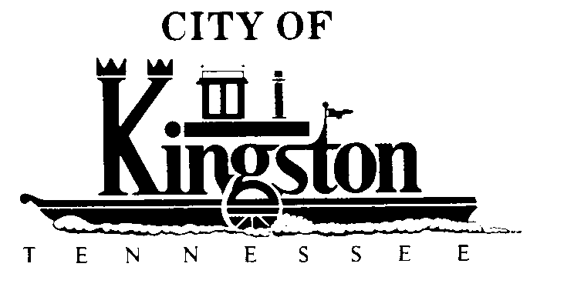

WORK SESSION - KINGSTON CITY COUNCIL
MAY 3, 2011 – 6:00 P.M.
KINGSTON COMMUNITY CENTER – ROOM C

A G E N D A

- Call to order

- Invocation and pledge

- Discussion Regarding A Grant Contract Between the State of Tennessee, Tennessee Department of Environment and Conservation and the City of Kingston Playground Project

- Discussion Regarding Needs of the Library in Staff Report:
  - Roof $23,000
  - Fascia Board and Caulking $ 4,000
  - Carpet $20,000

- Discussion of National Night Out and Changing the Date for the Council Work Session From Tuesday, August 2 to Thursday, August 4, 2011, to Allow Council Members to Attend

- Discussion Regarding an Ordinance Replacing the Present City of Kingston, Tennessee Municipal Flood Damage Prevention Ordinance With an Updated Version and Updated Flood Insurance Rate Maps

- Discussion Regarding Closure a Portion of Sturgis Avenue (from Clinch Street to the end of Sturgis Avenue) at the Request of Calvary Baptist Church

- Discussion Regarding the State Planning Office

- Discussion of Changing the Date for the Council Work Session From Tuesday, June 7 to Thursday, June 9, 2011, to Accommodate Election Day

- Discussion Regarding the Annual TDOT Contract for Maintenance of State Highways Through Kingston, TN

- Discussion Regarding Changing the Kingston City Charter to Prevent a City Council Member From Also Holding Another Elected Office”

- Discussion Regarding Security Cameras

- Discussion Regarding a Candidate Forum to be Held on Thursday, May 12

- Discussion Regarding a Day of Recognition - Mayor Beets

- Discussion Regarding Christmas Lights - Mr. White

- Discussion Regarding:
  - First Reading of an Ordinance to Amend the Budget Appropriation Ordinance for Fiscal Year Beginning July 1, 2010, and Ending June 30, 2011, for the City of Kingston

- First Reading of an Ordinance Amending the Annual Budget for the Water and Sewer Department of the City of Kingston for the Fiscal Year Beginning July 1, 2010, and Ending June 30, 2011.

- First Reading of an Ordinance to Adopt the Budget Appropriation for Fiscal Year 2011/12 for the City of Kingston

- First Reading of the Ordinance Making and Fixing the Annual Budget for the Water and Sewer Department of the City of Kingston for the Fiscal Year 2011/12 and Establishing Water and Sewer Rates and the Expenses of the Operation of the Kingston Water and Sewer Departments

- Discussion Regarding Approving a Public Hearing On June 14 at 6:30 p.m. for:
  - An Ordinance to Amend the Budget Appropriation Ordinance for Fiscal Year Beginning July 1, 2010, and Ending June 30, 2011, for the City of Kingston

- An Ordinance Amending the Annual Budget for the Water and Sewer Department of the City of Kingston for the Fiscal Year Beginning July 1, 2010, and Ending June 30, 2011.

- An Ordinance to Adopt the Budget Appropriation for Fiscal Year 2011/12 for the City of Kingston

- The Ordinance Making and Fixing the Annual Budget for the Water and Sewer Department of the City of Kingston for the Fiscal Year 2011/12 and Establishing Water and Sewer Rates and the Expenses of the Operation of the Kingston Water and Sewer Departments

