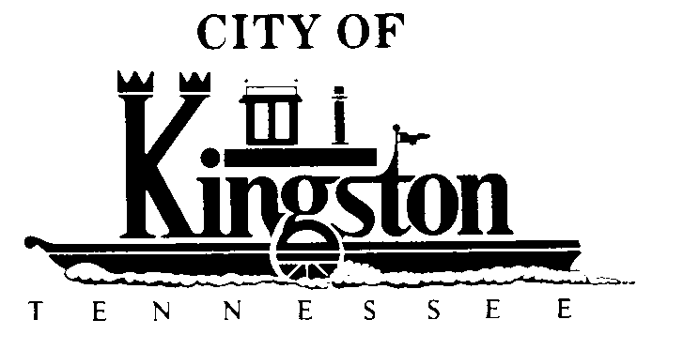

SPECIAL CALLED MEETING
KINGSTON CITY COUNCIL

KINGSTON COMMUNITY CENTER - COUNCIL CHAMBER
APRIL 26, 2013 – 5:30 P.M.

A G E N D A

- Call to Order

- Invocation and Pledge

- Roll Call

- Discussion and Possible Action Concerning the Process of Selecting a New City Manager - Warren Nevad, UT-MTAS Consultant

