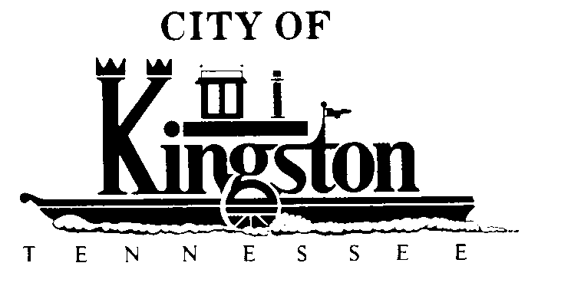

WORK SESSION - KINGSTON CITY COUNCIL
April 3, 2012 – 6:00 P.M.
KINGSTON COMMUNITY CENTER – ROOM C
A G E N D A

- Call to order

- Invocation and pledge

DISCUSSION REGARDING THE FOLLOWING ITEMS:

- Letter to Roane County Regarding In Lieu of Tax Payments - Vice Mayor Neal

- Amendment to the Beer Ordinance - Vice Mayor Neal

- An Ordinance Reducing the FY 2012 Tax Rate From $1.0834 to $1.034

- A Committee Report Regarding Making Court Street a One-Way Street - Councilman White

- Amendment to the Debt Management Policy

- FY 2012-2013 Draft Budget

