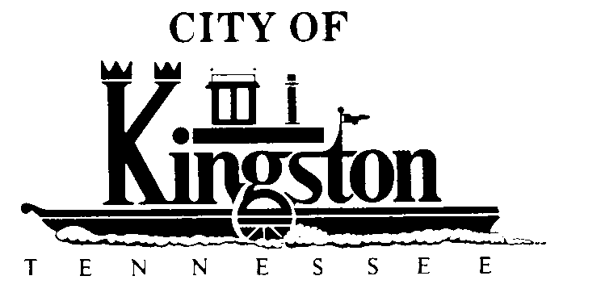

WORK SESSION - KINGSTON CITY COUNCIL
August 7, 2012 at 5:00 P.M.
COMMUNITY CENTER – ROOM C
A G E N D A

- Call to order

- Invocation and pledge

DISCUSSION REGARDING THE FOLLOWING ITEMS:

- Kingston United Methodist Church Request to Close West Church Street on August 19, 2012, From 1 p.m. to 6 p.m. for Their Annual Back to School/Church Bash

- Dispatch Agreement for Fiscal Year 2012/2013

- Quarterly Report - Ms. Brewer

- Change Order #1 - Wastewater Treatment Plant Expansion - Mr. Pinkerton

- Solar Energy - Mayor Beets

- Signing Ceremony With Covenant Health at the New City Hall Building at 2:00 p.m. on August 21, 2012 - Mayor Beets

- Executive Session Re: Lawsuits - Mr. McPherson

