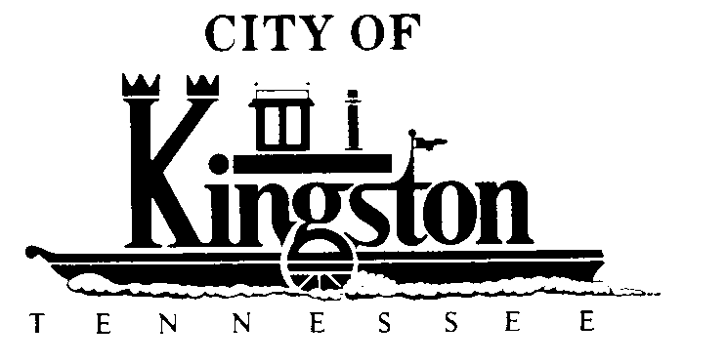

WORK SESSION - KINGSTON CITY COUNCIL
FEBRUARY 5, 2013 at 6:00 P.M.
COMMUNITY CENTER – ROOM C

A G E N D A

- Call to order

- Invocation and pledge

DISCUSSION REGARDING THE FOLLOWING ITEMS:

- Update on the July 4th Boat Races - Mr. Ross

- Adopt a Resolution to Establish an Updated Occupational Safety and Health Program Plan, Devise Rules and Regulations, and to Provide for a Safety Director and the Implementation of such Program Plan

- Update on New Building - Mr. Pinkerton

- Increase Spending Authority of the City Manager Pertaining to Expenses of Renovating the New City Hall

- Adopt a Resolution Regarding the 911 Board

- Waterline Extension to Increase Flow to Gallaher Road Corridor

- Bids for Additional Projects (Gallaher Road, Collection Lines and Force Main Extension on Paint Rock Ferry Road) - Mr. Pinkerton

- Loan Closings

- Quarterly Report - Ms. Brewer

