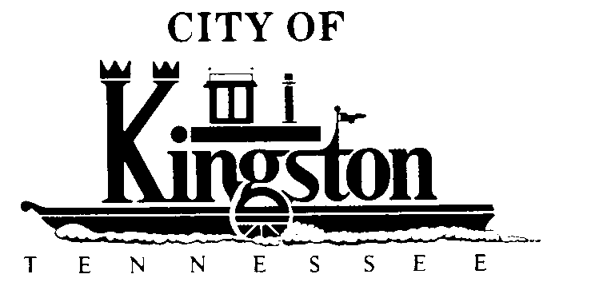

WORK SESSION - KINGSTON CITY COUNCIL
November 5, 2013 at 6:00 P.M.

CONFERENCE ROOM - CITY HALL
900 Waterford Place

A G E N D A

- Call to order
- Invocation and pledge
DISCUSSION REGARDING THE FOLLOWING ITEMS:
- Greenway Project--Contract 2, Danl Hall
- Update on the Sewer Plant Expansion – Steve Holtermann, P.E.
- An Ordinance to Amend Title 11, Chapter 6, of the Kingston Municipal Code by Adding Section 11-611, Regulating the Sale of Ephedrine or Pseudoephedrine Related Products Within the Municipal Boundaries of the City of Kingston, Tennessee

- MOU Green Waste Project Study
- Tennis Courts Agreement – Councilman Brown
- Signs at Ft. Southwest Point Sports Complex – Councilman Brown
- Library Issues – Councilman Byrkit
- Employee Benefits
- STP Funds
- Solar Farm
- Reappointment of Mr. Chuck Hutzler to an 8-Year Term on the Planning Commission (New Term Beginning November 1, 2013 and Ending October 31, 2021)

