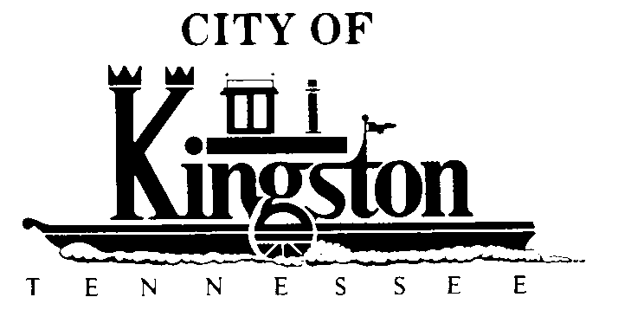

WORK SESSION - KINGSTON CITY COUNCIL
September 3, 2013 at 6:00 P.M.

CONFERENCE ROOM - CITY HALL
900 Waterford Place

A G E N D A

- Call to order
- Invocation and pledge
DISCUSSION REGARDING THE FOLLOWING ITEMS:
- Update on Greenway Project
- Update on Solar Power Project
- Update on the Sewer Plant Expansion
- AirEvac Insurance
- Overtime Policy
- Second Reading of an Ordinance to Fix the Time and Place of Regular Meetings of the Kingston City Council

- Second Reading of an Ordinance to Establish a Financial Review Committee to Provide for the Number, Manner of Appointment, Length of Term and Advisory Duties of the Members of the Committee

- Second Reading of an Ordinance to Amend the Ordinances of the City of Kingston to Remove Statements on Applications for Liquor Licenses Relative to Domicile and Residency

- Dispatch Agreement for 2013/2014 Fiscal Year
- Beer Permit Application – Rocky Top Market #901

